Hospital Management System

Intern Details
Intern ID : CITS3089
Full Name : Sasidhran
No. of Weeks : 4 Weeks
Project Name : Hospital Management System

Project Scope:
The Hospital Management System is a web-based application developed using HTML, CSS, and JavaScript. It helps manage hospital operations such as patient registration, doctor management, appointment booking, billing, and report generation.

Features:
- User Login
- Dashboard
- Patient Registration
- Doctor Management
- Appointment Booking
- Billing System
- Reports Page

Technologies Used:
- HTML5
- CSS3
- JavaScript
User Login:
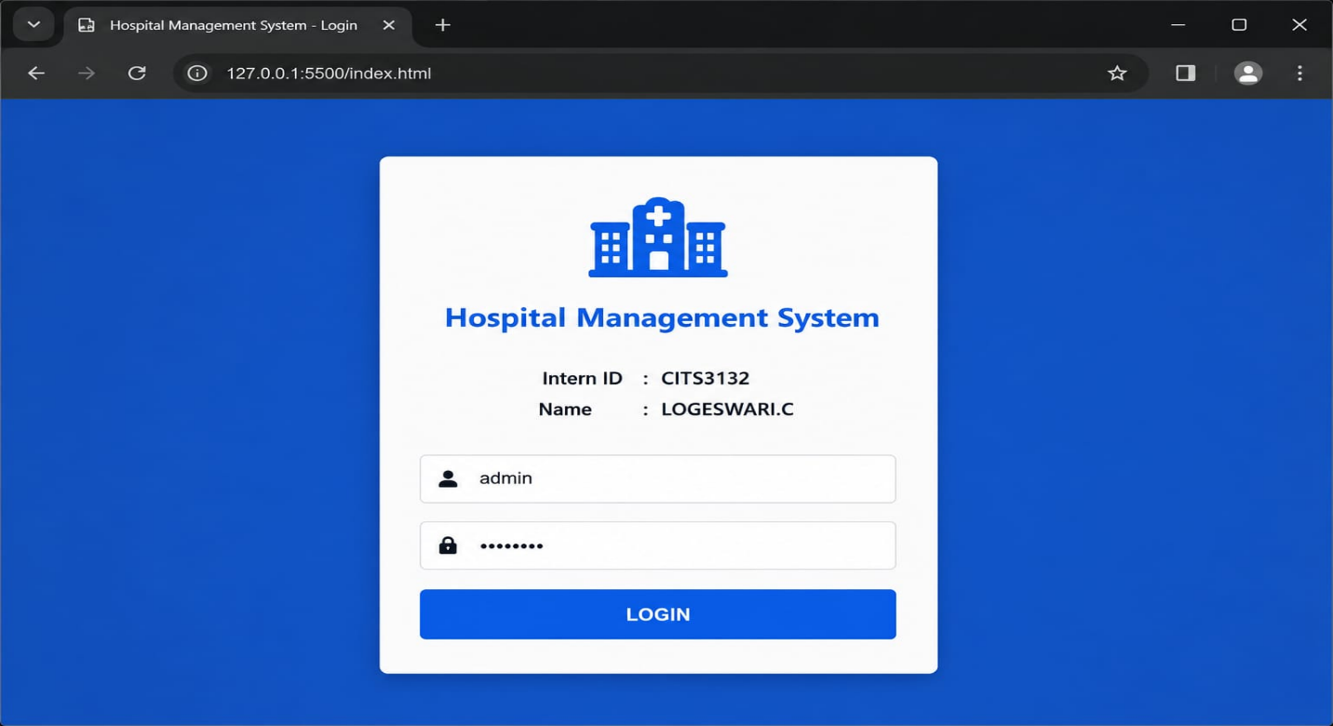

Dashboard:
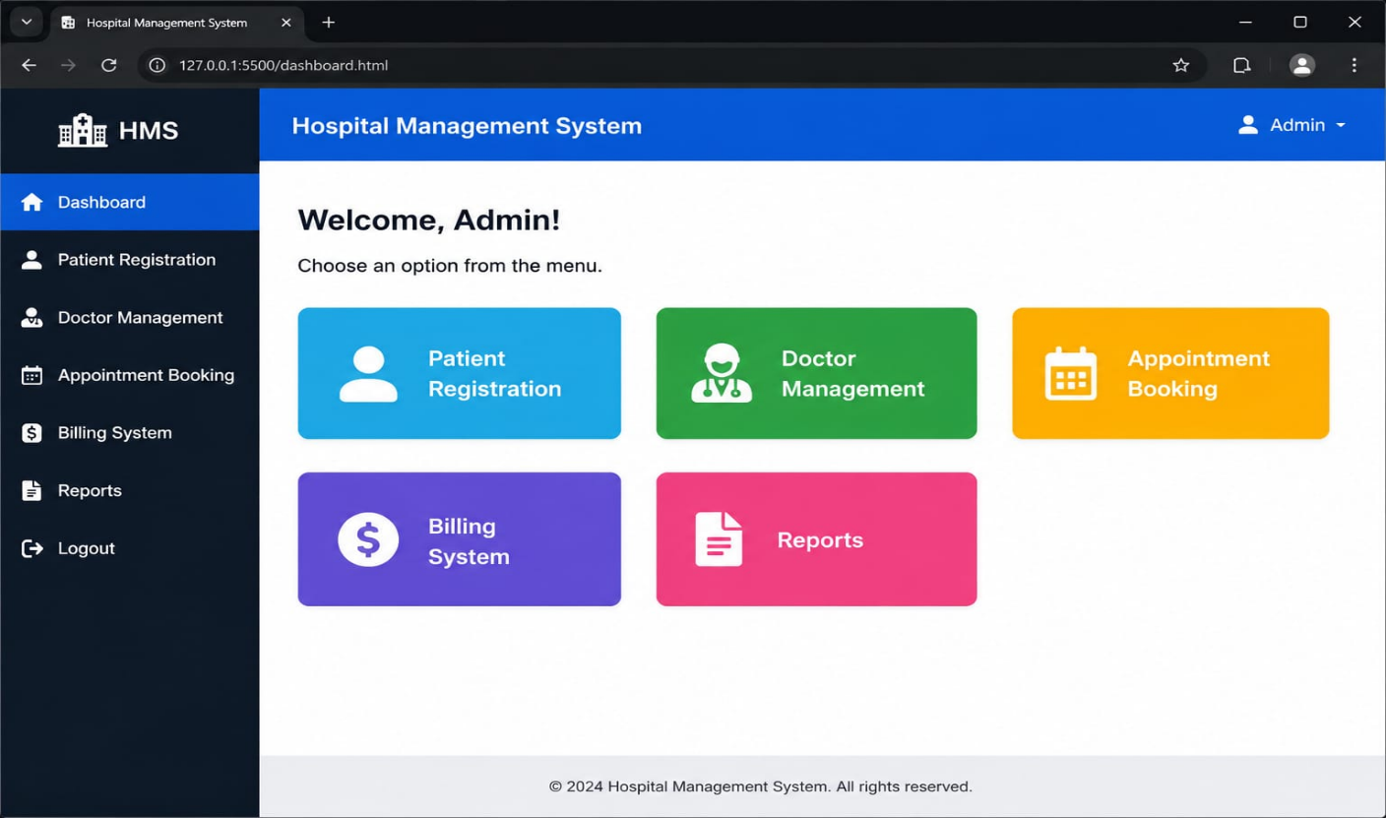

Patient Registration:
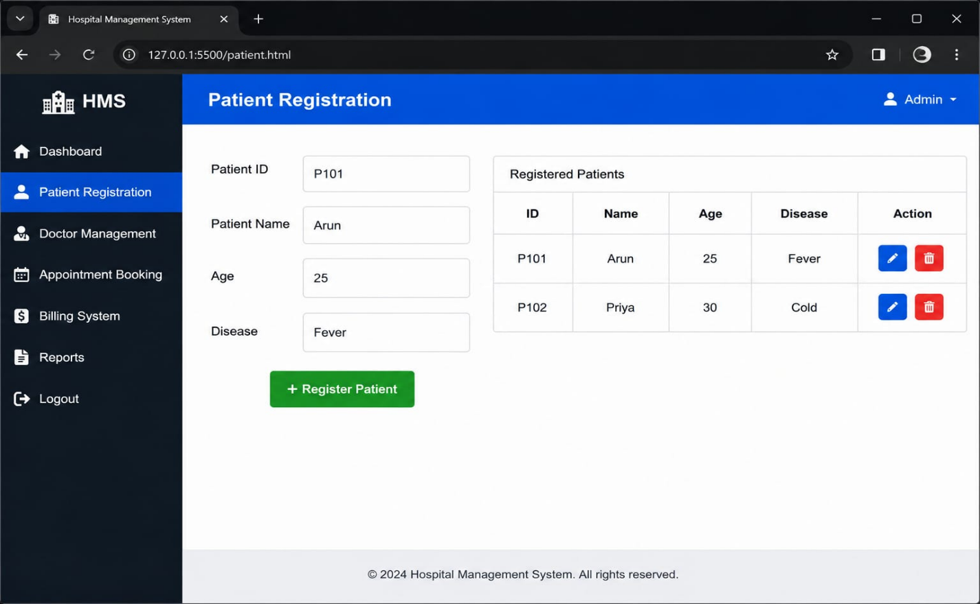

Doctor Management:
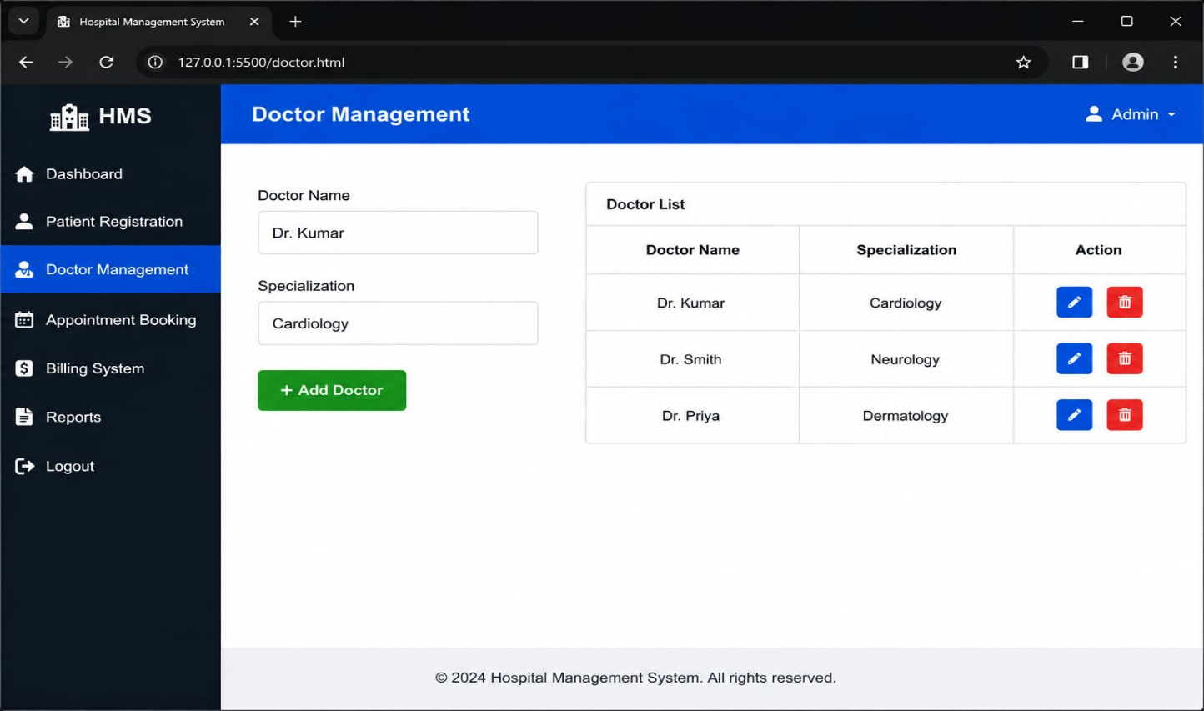
Appointment Booking:
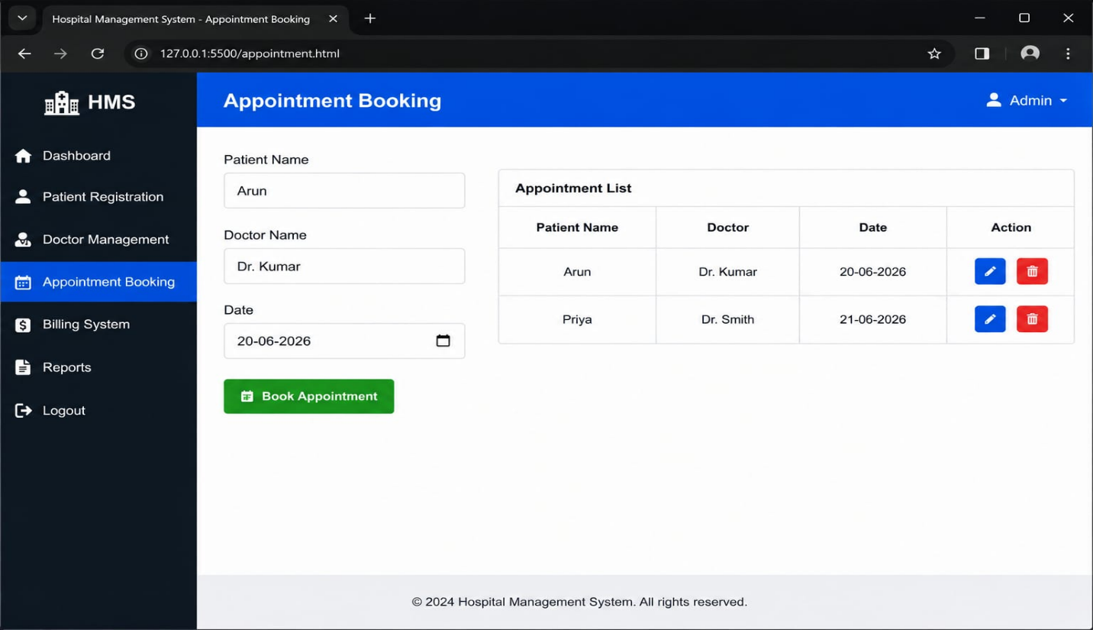

Billing System:
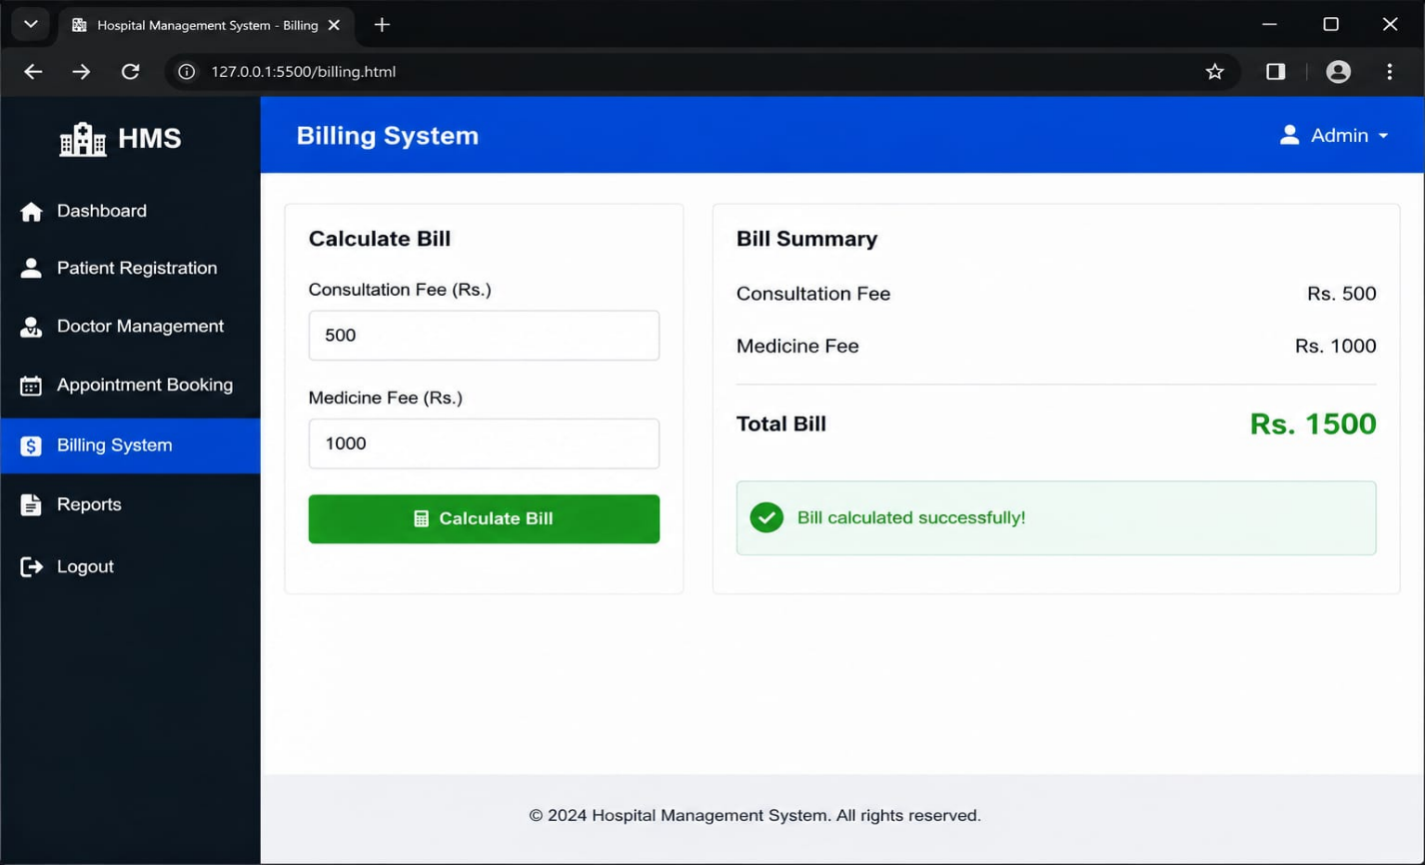

Reports:
